Westfield Church: Sunday 14th April
Valerie writes: Teach us to pray
It's hard knowing how to pray isn't it? There are so many complex problems in the news and all around us; wars, climate change, persecution, corruption. Where do we start? How do we know what to prioritise and the right things to pray about?
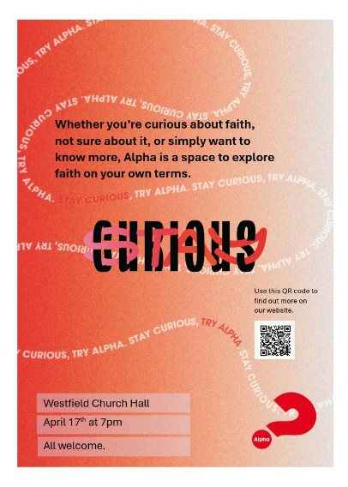
I find this prayer by Eddie Askew helpful when I feel overwhelmed with the burden of many different and difficult situations to pray about. Sometimes silence is enough.
Sometimes Lord, often -
I don't know what to say to you,
But I still come, in quiet, for the comfort of two friends
Sitting in silence.
And it's then, Lord that I learn most from you.
When my mind slows down and my heart stops racing.
When I let go and wait in the quiet,
Realising that all the things I was going to ask for
You know already.
Then, Lord, without words, in the stillness,
You are there...
And I love you.
Lord, teach us to pray.

Sunday April 14th
8.00am: BCP Holy Communion
9.30am: Café Church in the church hall (hot drinks and croissants from 9.00am)

This week
Tuesday 7.30pm: Prayer Group at 24 Greenacres
Wednesday:
9.30am: Holy Communion
10.30am: Community drop in at church
7.00pm: Alpha course, starting with a meal: church hall, all welcome
Alpha from Wednesday 17th April: 7.00pm, church hall, then ten Wednesdays
Alpha is a series of group conversations that freely explore the basics of the Christian faith in an open, friendly environment. Everyone’s welcome. No matter your background, your doubts or your or beliefs, you are invited to as many as you want to attend. Come along and try out the first session and enjoy the meal with no obligation to continue with the other sessions if it’s not for you.
Every week will have three things in common: a meal, a video, and conversation in smaller groups to share your thoughts and questions on the session’s topic. You can say anything you like, or nothing at all. It’s your Alpha, on your terms.
To book your place(s) and let us know about special dietary requirements please email paforfgw@gmail.com by 15th April

Sunday April 21st
8.00am: BCP Holy Communion
9.30am: Holy Communion, with FSW collection
Family Support Work particularly need: tinned fruit; tinned meat (not fish); tinned vegetables (not pulses); tinned tomatoes; coffee; long grain rice; jam; ketchup; squash and baking items as well as cleaning products; toilet rolls; toothpaste and shampoo. Things not currently needed: biscuits; cereal; teabags; soup; baked beans, nappies

Friends Spring Fair, April 20th
Friends of Westfield Parish Church are holding their annual Spring Fair in the church hall next Saturday 20 April from 10.00am until noon. Admission is £1 (children free) which includes tea or coffee. All welcome.
Donations of cakes or preserves and suitable prizes for the raffle would be welcome.

Welcome

We hope you enjoy your visit or time with us and that you will be inspired and helped. We gather together every week to encourage one another to be equipped as live out our Christian discipleship at home, at work or wherever we are placed.
During the week, there are several different services and small group meetings, each of which has a distinctive feel and tempo. In all of them we reflect on our own lives and the wonderful promise of forgiveness and try to learn more of God and his son Jesus in a way that will change our lives and behaviour. You are welcome to attend any or all of them.

Popular questions…
What about communion?
Everyone who normally receives communion is welcome to share in the bread and wine (which is served by the vicar who dips the bread wafer into the wine before handing it to you). If you would like a blessing, but not communion, please keep your hands to your sides when the bread is offered to you. Non-alcoholic wine and gluten free bread is available (ask the vicar at the table). If you want communion in your seat, please say so.
Can I have communion at home?
If you, or someone you know, are unable to get to our services and would like to have communion in their home, please email dawnwestfield@aol.com and we can arrange for one of our licenced lay ministers to visit and share the bread and the wine using the approved liturgy.
Children, what happens if they are noisy?
We love having children in church so don’t worry about them making a noise or moving around.
Dogs and other pets, are they really welcome?
You are always welcome to bring your dog to all our services. Typically, there is at least one dog at the 8.00am Sunday service and the 9.30am Wednesday service.
Toilets: where are they?
Our toilets just inside the church hall. There is an accessible toilet and baby changing facilities.
Is there a collection?
We do not want anyone to feel any obligation to give to the work of the church or put anything in the offering bag or plate. Most services don’t have a collection.
Baptisms, weddings, blessings, funerals and thanksgivings – can I have them in church?
To arrange a celebration or ceremony at St John’s, please email to Sandi Wickens revsandiwickens@gmail.com or call 07395 106514 to speak to her.
Can I make prayer requests?
If you would like a situation prayed about, please contact Dawn 01424 255423 /
0750 7745 159 or email dawnwestfield@aol.com.

Who can I contact?
Priest in charge: Rev Sandi Wickens –07395 106514 revsandiwickens@gmail.com
Churchwardens: Dawn Archer - 07507 745159 dawnwestfield@aol.com
and Suzanne Bunton –07753 430197
Safeguarding: Cathy Williamson - 07765 258012,
Parish administrator: Jayne Stevens – 07716 349964 paforfgw@gmail.com

