**Westfield Church Notices Sunday 20th April**

**Valerie writes:**

First Light

Much later I stand mute, awestruck beneath

The moon and stars which Thou hast made.

Smell in Spring's wet earth, Easter Day's first light

Silently creeping over hill and field,

Just as Christ's rising, forever's first dawn.

Blossoming outside the church's confines.

By Bonnie Thurston

**Easter at Westfield Church:**

**Sunday April 20th**

Easter Sunday Holy Communion 8am and 9.30am

Sunrise Celebration 5.45am

**Messages:**

**Church Electoral Roll**

Pease could forms for enrolment onto the Church Electoral Roll and the accompanying GDPR form be returned to Marian Newman – Electoral Roll Officer **by 20th April** at the latest in person or via email: Subject Heading “Westfield ER” to [paforfgw@gmail.com](mailto:paforfgw@gmail.com) or placed in the black post box in the Church porch.

**Home Groups**

Both groups restart after Easter on 30th April. We start at 7:30 pm.

All are welcome.

**Toddler Group**

Usually at this time of the year we are looking forward to opening up the toddler group again but for this to happen we’re needing a little help please. There are occasions when Ann and Sandi can’t be around on Wednesday afternoons, 1pm - 3pm, so we would like to add two more people to the team to ensure we don’t have to cancel at the last minute. If you are someone who enjoys meeting families, encouraging them and engaging with pre-school children please have a pray and a think about joining this small and happy team. Safeguarding training will be provided. Please speak to Ann G or Sandi to find out more.

God bless,  
Sandi

**APCM meeting dates**

4th May Westfield

11th May Guestling

18th May Fairlight

**FSM:**

Collection date for FSM is Sunday 20th April at Westfield Church and Wednesday (morning) 23rd at Kathy and Eric’s house

**FSW are currently in need of:**

Instant coffee

Dried rice

Ketchup

Mayonnaise and other spreads

but NOT cereal.

**What’s On:**

**Sunday April 20th**

8.00am: Prayer Book Communion

9.30am: Celebration of Holy Communion for Easter Day

**Wednesday April 23rd**

9.30am Holy Communion at 8.30am

10.30am Warm Space Community Hub

**Wednesday April 30th**

Care For What You Believe 6.30pm

Join Celia and Lyndon Bowring as they host a Pray for the Nation Evening

The Spa Hotel, Royal Tunbridge Wells, TN4 8XJ

Care.org.uk/events or 020 7233 0455 for further details

**Sunday 4th May & Monday 5th May**

Westfield Community Association, in association with the Parish Council, will be hosting a free exhibition of Westfield memories and recollections of everyday life to mark the end of WW2 and the 80th Anniversary of VE Day. This will be in Westfield Community Hall from 10.30am on Sunday 4th and Monday 5th May. See the back page of your February-May Westfield Community Newsletter (spare copies in The New Inn or Strawberry Fair) for more information.

Janice

**Saturday 10th May**

Please find following poster for the Diocesan Vocations Day being held on Sat 10th May at St Mary's Church, Horsham.

**Wednesday May 14th**

Rye Deanery trip to Chichester Cathedral

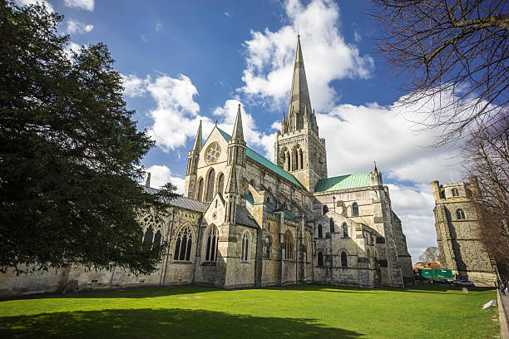

Come and join us on a day-trip journey to Chichester Cathedral – our Mother Ship, in this the 950th year of our Diocese.

We will be leaving in the morning and can arrange to have a Eucharist especially for us at lunchtime, followed by a meal, if you would like to. Tours of the Cathedral can be arranged if you would like to do this.

If you are interested, please let Rev. Kate Bailey know as soon as possible. If enough people would like to join us, then we will look into the cost and availability of coach hire, as well as the lunch and tour costs of the Cathedral.

We hope that as we travel as a Deanery, we will find ourselves joined closer together in our faith, as we visit the heartbeat of our Diocese.

Rev. Kate Bailey

01797 253118 [rector@stmaryschurchnorthiam.co.uk](mailto:rector@stmaryschurchnorthiam.co.uk)

**Prayer:**

If you would like a situation prayed about urgently, please contact the church Prayer Share. Contact Dawn 01424 255423 / 0750 7745 159

If you know anyone who would like to be added to the notices, please send me an email with their details. If you don’t want to receive this email each week, or would rather receive it in a different format, please let me know.  
Please give information for notices to me by Thursday morning (contact details below).

Have a good week everyone,

Tony Demarco

[tonydemarcohastings@gmail.com](mailto:tonydemarcohastings@gmail.com)