Westfield Church Notices Sunday 24th August

Valerie writes:

Waiting
Waiting is difficult, isn't it?
The American writer Sue Monk Kidd describes waiting as a time of preparation.
She looks at a cocoon spun by a caterpillar and explains that nothing seems to be happening, but in fact momentous changes are taking place within the cocoon and in time the butterfly with emerge.
Waiting comes to us all at times in our lives and the length of waiting is not in our hands.

A Prayer by Eddie Askew
I'm still waiting Lord,
Is there a chance
that you could reassure me
that the waiting's purposeful?
That in the silence and the dark
your will is working out
it's possibilities?
I don't know what's to come
but that no longer matters
quite so much
as knowing that
whatever it may be
you'll be there on the road with me.
The promise made reality.

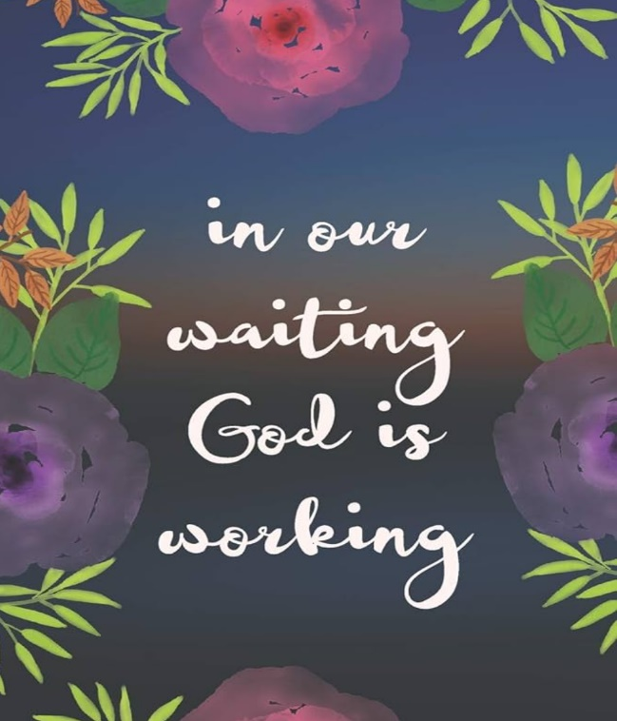

What’s on:

Sunday 24th August
8.00am: Prayer Book Communion
9.30am: Holy Communion

Wednesday 27th August
9.30am: Holy Communion
10.30am: Warm Space Community Hub
7.00pm: Wednesday Supper – Brenda 24 Greenacres
Please bring Plate, bowl, glass & cutlery and a dish to share

Wednesday Suppers through August: All are Welcome 7pm
August 27th Brenda 24 Greenacres
Please bring Plate, bowl, glass & cutlery and a dish to share

FSW Collection:
Collection for this months FSW will be on Sunday 24th August at Westfield Church or by Wednesday morning 27th August to Kathy and Eric’s house.
FSW would be grateful for the following items:
Tinned fruit
Pasta/curry sauces
Rice (dry and microwaveable)
Chopped tomatoes.

Prayer:

If you would like a situation prayed about urgently, please contact the church Prayer Share. Contact Dawn 01424 255423 / 0750 7745 159

If you know anyone who would like to be added to the notices, please send me an email with their details. If you don’t want to receive this email each week, or would rather receive it in a different format, please let me know.
Please give information for notices to me by Thursday morning (contact details below).
Have a good week everyone,
Tony Demarco tonydemarcohastings@gmail.com

