Westfield Church Notices Sunday 30th November

Valerie writes:
Advent
We will soon be in Advent, a time of waiting as we journey towards Christmas.
Let's take time to pause this Advent amidst the Christmas preparations, as we reflect on the event that changed the course of the world forever.
Let's look forward with hope as the light of God shines out in the darkness.
O Come, O Come, Emmanuel.
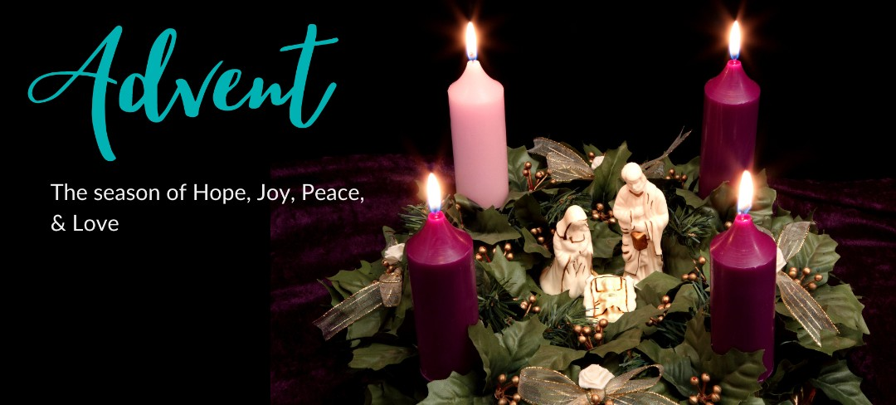

What’s on:

Sunday 30th November
8.00am: Prayer Book Communion
10.30am: Joint Service at St Andrews Church, Fairlight
Tuesday 2nd December
7.30pm: Prayer Group at Brenda’s
Wednesday 3rd December
9.30am: Holy Communion
10.30am: Warm Space Community Hub
7.30pm: Home Groups at Dawn and Jess’ and Cathy and Howard’s

Messages:

Please find attached the Guestling and Fairlight Parish newsletter for this week. Thank you to everyone who contributed to this week's newsletter.

A reminder that this Sunday's service at St. Andrew's starts at 1030.

Don't forget to reserve your places (and menu options) for the Christmas meal on the 16th December. It promises to be a great evening, and everyone from all our churches is invited!

Thanks & best wishes,
Sarah Lewis
Parish Administrator

FSW

On behalf of Family Support Work, a big thank you for all your generous donations last week.

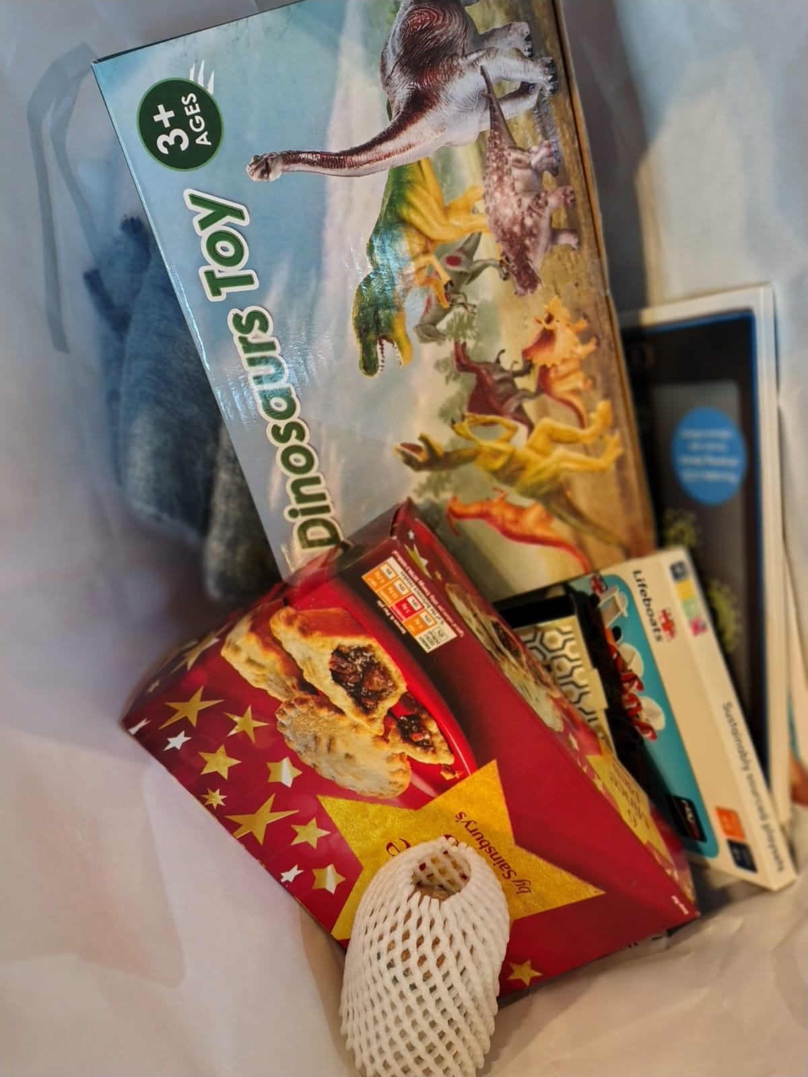

Tina from FSW is coming to talk to us in January so please let me know if you have any questions you would like to ask her.
Thanks again

Kathy and Eric.

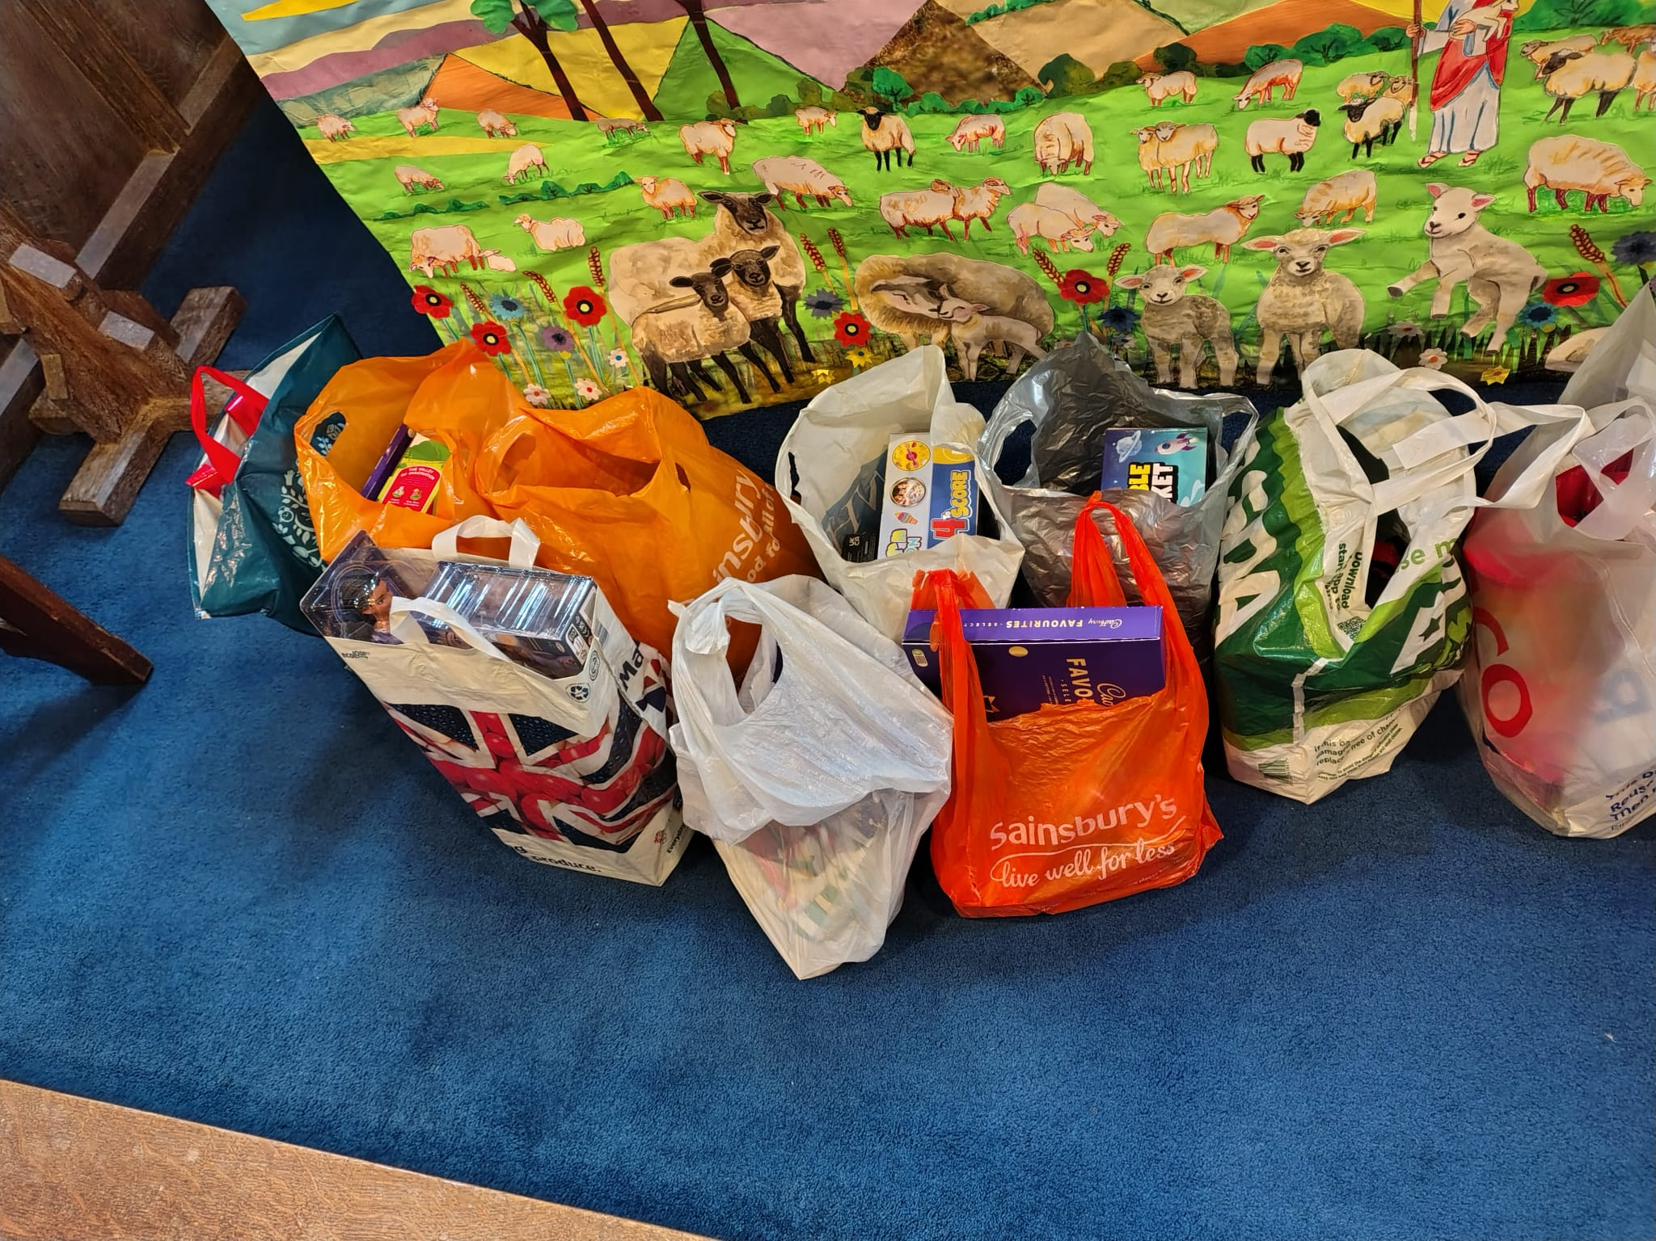


Pregnant with Hope
(Reflections for Advent)

Join us for an evening of reflections for Advent, along with poetry and music. The evening will be led by Professor Tina Beattie.

Tina is Professor Emerita of Catholic Studies at the University of Roehampton in London and a well-known Roman Catholic theologian. She has published extensively on sacramentality, desire, embodiment and gender, engaging with psychoanalytical theory and art history as well as theology. She has a particular interest in Marian theology, art and devotion. She now works as an independent researcher and writer. In addition to her academic publications, Tina is also a published novelist and a regular contributor to the media, including BBC Radio 4’s “Thought for the Day”.

Please join us for what will undoubtedly be an interesting, thought-provoking and stimulating evening.

Date: Wednesday December 10th, 2025

Time: 7.00 pm

Venue: St Thomas the Apostle Church, Camber, New Lydd Rd, TN31 7RJ

Wine and cheese will be served after the talk.

There’s plenty of parking in both the church grounds and the neighbouring street.
For more details, please contact The Revd. Jacques Desrosiers, on 07931 217458 (including WhatsApp) or email jtmdesrosiers@gmail.com.

Carols by Candlelight 14th December 6pm

Sandi would like to have a robed choir for this lovely service, so we need the help of singers from the congregation. We hope to sing two anthems (not too difficult) as well as two or three descants. There will be two or three practices, probably on Thursdays (TBC) from 27th November. Please let Janice know if you can help.

Church Christmas Dinner

7.00pm Thursday 16th December at Fairligh Lodge Hotel, see attached for details

Benefice Reorganisation

Sandi has asked me to bring your attention to the proposed Benefice Reorganisation. You’ll find a copy of the draft proposal, and the full document explaining the proposed reorganisation of Fairlight, Guestling and Westfield into a single Benefice in the New Year, attached to this email. Paper copies have also been displayed in all our churches, for your review. Please note that the draft proposal contains details of where to write should you wish to comment at this stage of the consultation. The closing date is 1st December.
Sarah Parish Administrator

Prayer:

If you would like a situation prayed about urgently, please contact the church Prayer Share. Contact Dawn 01424 255423 / 0750 7745 159

If you know anyone who would like to be added to the notices, please send me an email with their details. If you don’t want to receive this email each week, or would rather receive it in a different format, please let me know.
Please give information for notices to me by Thursday morning (contact details below).
Have a good week everyone,
Tony Demarco tonydemarcohastings@gmail.com

