Westfield Church Notices Sunday 3rd May

Valerie writes:

Discipline

How exciting it was to watch the London Marathon last Sunday; the determination, the resilience and the endurance of the runners were truly inspiring.

This year we had a personal connection too, as our younger son Jon was running for 'Think Forward' a Special Needs project at his school.

Discipline to train and prepare takes months before a marathon. Jon has been getting up at 5 a.m. throughout the long winter months, while his young family still slept, to run in the dark with a head torch shining his way. Discipline usually involves sacrifice in some way.

It's interesting that the words 'discipline' and 'disciple' come from the same Latin root, 'discere' meaning 'to learn'. Discipleship is shaped by the discipline to grow.

Father God, help us to remain firm as we seek to grow in our love and knowledge of you. Amen

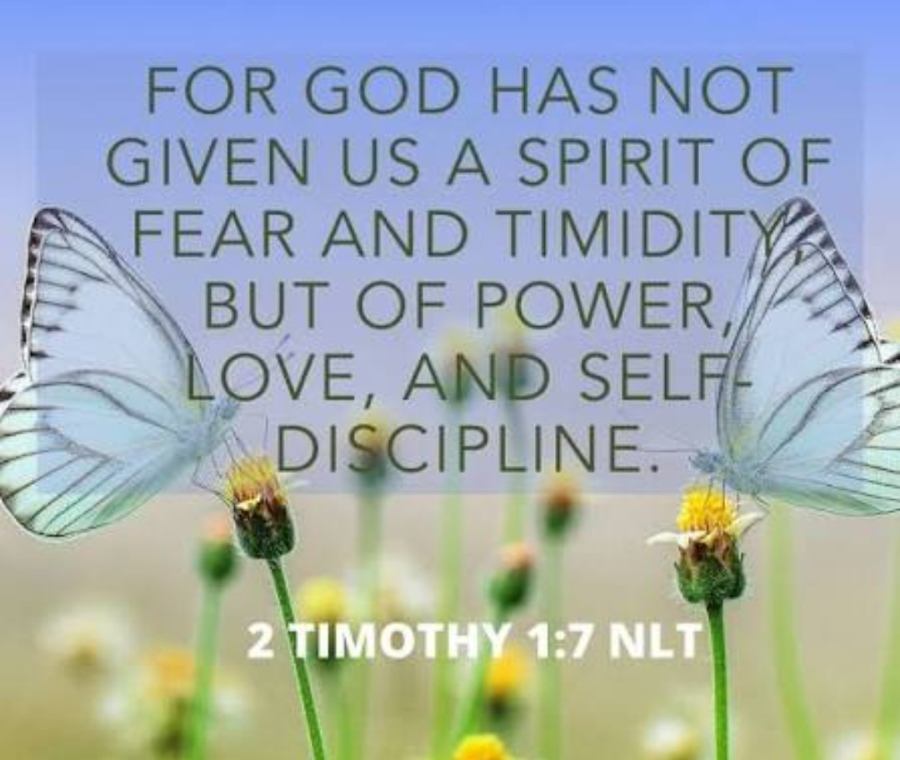

What’s on:

Sunday 3rd May
8.00am: Pray Book Communion
9.30am: Holy Communion

Tuesday 5th May
7.30pm: Prayer Group at Brenda’s

Wednesday 6th May
9.30am: Holy Communion
10.30am: Warm Space Community Hub
7.30pm: Home Group (Cathy and Howard’s group will meet at Kathy and Eric’s house)

Messages:

Friends of Westfield Parish Church

Last Saturday's Spring Fair raised £321. Thank you to everyone who helped and supported us. Jim.

Guestling and Fairlight

Please see attached Guestling and Fairlight Parish Newsletter

Sarah – Parish Administrator

Bishop of Chichester

Bishop Martin retires at the end of May, and as a diocesan family we are beginning the search for his successor. Have your say in the appointment at tinyurl.com/next-bishop It will take only a few minutes to complete, and it is open until May 26th. We welcome responses from everyone.
Find out more about the process for appointing our next bishop at www.chichester.anglican.org/vacancy-in-see/

OFFLINE VERSION: there is also an offline version of the survey which is attached

More information on the process is available at: www.chichester.anglican.org/vacancy-in-see/

With best wishes

John Preston
Diocesan Secretary

ECO Awards

We've looking forward to celebrating all churches with Eco Awards on May 10th at the Cathedral for evensong at 3pm- with cake/tea afterwards. Do encourage parishes to let me know how many are coming along.

Diocesan Environment Day May16th at St Peter's Bexhill 10-4pm. £5, https://www.trybooking.com/uk/events/landing/103990
Please book ahead so we can allocate you to the workshops. There's an exciting range of speakers- including Polly Eaton from A Rocha.

Best wishes
Buff
Diocesan Environment Officer,

Greg Moore, the Diocesan Officer for Lay Ministry and Training writes:

I’m delighted to share that the new Authorised Lay Ministry prospectus for 2026/27 is now live on the diocesan website. Alongside our well-established courses, we are pleased to be offering two new electives: Children’s Ministry and Leading Intercessions.
All information has been fully updated, with 12 electives and 17 courses running in total. You’ll find everything in one place on the webpage, with all application forms conveniently located at the bottom.

Authorised Lay Ministry - Diocese of Chichester

The Authorised Lay Ministry (ALM) training programme offers flexible, skills-based formation for lay people who are called to serve in public ministry within their local church. ALMs play a vital role in supporting and enriching parish life, contributing to the Church’s mission through a wide range of ministries.
In the current academic year, we are offering twelve ministry electives, with seventeen courses running in total. New electives this year include Children’s Ministry and Leading Intercessions.
While the shape of ALM ministry varies according to parish context, ALMs typically work as part of ministry teams—leading, supporting, or collaborating as appropriate. They are also encouraged to help identify, nurture, and develop the gifts of others within their communities.

Please hold in your prayers the 110 ALMs who will be commissioned by Bishop Ruth on 9th May at the cathedral (including four people from our Benefice).

God bless,
Sandi

Open Ears

My name is Kevin, and I look after the marketing for Open Ears, a small Christian charity passionate about supporting people affected by hearing loss. I’m excited to tell you about our new free, live online training session: An Introduction to Hearing Loss Awareness.

This practical, one-hour session is hosted by Emily Owen, author, speaker, and Trustee of Open Ears. It will help participants understand what hearing loss is, how it affects people, and the everyday barriers that can make church life and events challenging for those who are hard of hearing.

We would be delighted if you could share this with your congregation and invite anyone who is interested to join. It’s a wonderful opportunity for everyone to learn how to support people who are hard of hearing to help make church more inclusive.

Dates and Times:

- Wednesday 13 May 2026 – 2:00pm
- Tuesday 19 May 2026 – 7:00pm
(Join whichever session suits you – via Zoom!)

Sign up here: https://www.openears.org.uk/hearing-loss-awareness-training

If you have any questions, please don’t hesitate to contact me.

With every blessing,
Kevin
Marketing, Open Ears

Prayer:

If you would like a situation prayed about urgently, please contact the church Prayer Share. Contact Dawn 01424 255423 / 0750 7745 159

If you know anyone who would like to be added to the notices, please send me an email with their details. If you don’t want to receive this email each week, or would rather receive it in a different format, please let me know.
Please give information for notices to me by Thursday morning (contact details below).
Have a good week everyone,
Tony Demarco tonydemarcohastings@gmail.com

